Investigating beat-based temporal processing in Parkinson ’s disease

Megan Fung
Honours Psychology Thesis
Department of Psychology
University of Western Ontario
London, Ontario, CANADA
April, 2018

Thesis Supervisor: Jessica Grahn, Ph.D

Abstract
A beat is a perceived pulse at regular intervals of a sequence of tones. Humans tend to synchronize their movements to this regular perceptual accent. Therefore, beat perception is both a temporal and motor process. Previous literature has found an association between the basal ganglia activity and beat perception. Individuals with Parkinson’s Disease (PD) have basal ganglia impairments and have been shown to exhibit temporal and motor impairments. The current study looks at behavioural measures of beat perception, comparing one Parkinson’s disease patient to seven healthy controls. Participants completed both a rhythm discrimination task and a rhythm reproduction task in a single session. Half of the rhythms presented had a beat-based structure and the other half did not. Performance on each task was assessed as measures of beat perception. Firstly, we hypothesized that healthy participants would perform better on beat-based rhythms than non-beat-based rhythms. Secondly, healthy controls would have better beat perception than PD patients. Finally, we did not expect to find any difference in performance between beat-based and non-beat-based rhythms in PD patients. Impairment of beat perception in participants with PD could provide converging evidence of a role of the basal ganglia in beat perception. We did not find any effects of group in either task. No significant effect of rhythm type was found in the rhythm discrimination task, however both groups performed better on beat-based rhythms than non-beat-based rhythms in the rhythm reproduction task. All participants reproduced shorter rhythms better than longer rhythms. Results are consistent with the hypothesis that rhythms with a beat-based structure are more easily remembered and reproduced than rhythms without a beat-based structure, however results are not consistent with a beat-based impairment in Parkinson’s Disease.

Investigating beat-based temporal processing in Parkinson’s Disease
Beat Perception
Beat perception is both a temporal and motor process, recruiting a number of underlying neural and cognitive mechanisms including mental timekeeping, and the coordination of motor and auditory systems (Patel, Iversen, Chen, & Repp, 2005). It is important to define beat and distinguish it from rhythm. A rhythm is a sequence of tones; however, the beat is the recurring underlying pulse at regular intervals in a rhythm.
Timing mechanisms are required for beat perception. Evidence in the literature suggests that beat perception is driven by the temporal properties of the rhythm, rather than other cues, such as pitch or amplitude (Brochard, Abecasis, Potter, Ragot, & Drake, 2003). Rhythms with varying amounts of metricality, or timing structure, have been used to study internal timing mechanisms in individuals. Metric simple (ms), or beat-based rhythms, use a regular grouping of tones to induce a salient perceptual accent in the listener (Essens & Povel, 1985). Metric complex (mc), or non-beat-based rhythms, lack this regular grouping of tones, such that the underlying pulse is less noticeable.
Common paradigms designed to study beat perception include rhythm discrimination and rhythm reproduction tasks. In the rhythm discrimination task, participants are presented with either a ms or mc rhythm, followed by another rhythm of the same metricality. Participants are asked to indicate whether this new rhythm was the same as or different from the first rhythm they heard. In the rhythm reproduction task, participants are presented with either a ms or mc rhythm and are asked to tap the rhythm back from memory. These tasks provide a valid measure of beat perception as rhythms that are encoded with a beat are more easily remembered. Povel & Essens (1985) found that rhythms that more strongly induce a perceptual beat, form better internal representations and are consequently more accurately reproduced than rhythms with a weak beat.
Humans have a natural tendency to synchronize movements (e.g. toe-tapping, head nodding) to beat-based rhythmic sequences. An fMRI study conducted by Grahn & Brett (2007) found an elevated level of activation in the basal ganglia and parts of the supplementary motor area when listening to metric simple rhythms, suggesting that these brain areas may mediate beat perception. Given this motor involvement, studying beat perception can also provide information on the coordination of motor and auditory systems. Walking is a complex rhythmic task, and Thaut, McIntosh, Prassas, & Rice (1992) sought to investigate the effect of auditory rhythms on temporal stride parameters in normal gait. Researchers found that when cued with auditory rhythms, participants improved stride rhythmicity between right and left lower limbs. Findings from this study indicate that auditory rhythms can be used as a neuromuscular rehabilitation technique to retrain muscle control in individuals with motor system neurological damage.
Parkinson’s Disease
Parkinson’s Disease (PD) is a neurodegenerative disorder, specifically, progressive cell death in the substantia nigra results in a decreased amount of dopamine release into the basal ganglia and regions of the midbrain. This dopamine deficit in the basal ganglia affects outputs, particularly motor, resulting in marked motor impairments, such as irregular gait (Alexander, 2004). There is no cure for Parkinson’s disease, however common treatment involves a dopamine agonist to replenish this depletion.
Patients with Parkinson’s Disease have been known to have marked difficulties in timing and movement (Harrington, Haaland, & Hermanowitz, 1998). This is likely due to the dopamine deficits in the basal ganglia. O’Boyle, Freeman, & Cody (1996) investigated temporal accuracy and precision in patients with Parkinson’s Disease, and the effect of dopaminergic medication. Participants were asked to finger-tap at a regular self-selected pace. This was conducted across two sessions, one with administration of dopaminergic medication (“on” medication), and one without (“off” medication). It was found that PD patients tapped at a less regular pace than controls on this task during the “off” medication condition and decreased this inter-tap variance when “on” medication. These results suggest that patients with Parkinson’s Disease are impaired on simple timing tasks, and dopaminergic medication seems to improve this motor timing.
A brain imaging study conducted by Jahanshahi et al. (1995) compared cortical activity during internally generated movements with externally generated movements. PD patients and their matched controls were asked to either finger tap at their own pace or asked to finger tap along to an imposed speed. Researchers recorded movement-related cortical potentials from various brain areas to obtain a readiness potential - a measure of electrical activity that occurs before voluntary movement. It was found that when movements were externally triggered, there was no significant difference in cortical activity prior to movement between the two groups. However, when asked to initiate self-paced finger-tapping, PD patients displayed a lower readiness potential than controls and a lower activation of the supplementary motor area. These findings suggest an underactivity of motor areas associated with motor timing tasks in Parkinson’s Disease, particularly during internally generated movements.
Beat Perception and Parkinson’s Disease
Understanding beat perception in Parkinson’s Disease can provide further understanding of timing mechanisms in Parkinson’s Disease, and how rhythmic auditory stimulation (RAS) can be used to tailor interventions for individuals with gait impairment. Thaut et al. (1996) implemented a 3-week RAS program in PD individuals with significant gait deficits, and found that participants had an improved gait velocity, cadence, and stride length.
Given the evidence that areas of impairment in Parkinson’s Disease are associated with areas of temporal processing, and the findings that dopaminergic transmission potentially decreases this impairment, a study conducted by Cameron, Pickett, Earhart, & Grahn (2016) sought to investigate the effect of dopaminergic medication on beat perception. This was a behavioural study, where PD patients and healthy controls completed a rhythm discrimination task, across two sessions – one medicated, and one unmedicated. A main effect of group was found, where participants with PD performed significantly worse than controls. It was also found that dopaminergic medication influenced PD performance on beat-based and non-beat-based timing differently, improving performance on beat-based rhythms but worsening performance on non-beat-based rhythms. These findings support previous evidence that beat-based timing is impaired in PD (Grahn & Brett, 2009). However, patients unexpectedly performed better on beat-based rhythms than non-beat-based rhythms. This could be due to a compromised validity in the rhythm discrimination task, as some rhythms could be easier to discriminate from others, thus performance could be a measure of working memory and cognition, rather than the ability to perceive beat.
The current experiment furthers the work of Cameron et al. (2016), comparing behavioural performance on tasks of rhythm discrimination and rhythm reproduction in Parkinson’s Disease patients with healthy, matched controls. As the rhythm reproduction task provides a more sensitive measure of beat perception, impairment would increase support for a beat-based timing impairment in PD. However, this is a more demanding motor task than the rhythm discrimination task, as participants must tap back the rhythm, rather than simply indicate same/different. Thus, the rhythm discrimination task is implemented in this study as well. Coupling the rhythm discrimination and reproduction tasks should allow for the disentanglement of beat perception ability from confounding measures such as working memory and cognition, or motor impairments.
It is hypothesized that PD patients will be significantly impaired on beat perception, compared to controls. This effect can be evidenced through a comparison of performance on metric simple rhythms compared to metric complex rhythms, in both the rhythm discrimination and rhythm reproduction tasks. Given that individuals retain beat-based rhythms more readily than non-beat-based rhythms, we predict that controls will both discriminate and reproduce metric simple rhythms better than metric complex rhythms. If PD participants are impaired in beat perception, neither beat-based nor non-beat-based rhythms should induce a sense of strong beat, so we predict that PD individuals will not display a significant difference in performance between the two rhythm types, on either task.
Method
Participants
We recruited one individual with Parkinson’s Disease (PD) and seven healthy controls (3 male) matched by age, sex, education, and amount of musical training (M_{age} = 67.25 years old and M_{musical training} = 7.5 years). All participants had normal self-reported hearing, free of any psychiatric or neurological conditions, and had normal cognitive functioning, according to the Montreal Cognitive Assessment (MOCA) (M = 28). All participants were maintained on their normal medication schedule throughout testing. The PD participant had a MDS-UPRS score of 20, with a Hoehn and Yahr stage (describes symptom progression of PD) score of 1. Control participants had a mean MDS-UPDRS score of 2.29, and all control participants had a Hoehn and Yahr score of 0. Testing was completed at the Brain and Mind Institute in the Western Interdisciplinary Research building at Western University. All participants provided informed, written consent in accord with the human research ethics board at Western University.
Materials
Assessments. Participants were administered the Bond-Lader Visual Analogue Scale (BL-VAS), a subjective mood rating scale. A 10 cm line is anchored at each line by opposite moods (ex. Calm and excited). Participants were asked to make a vertical mark at the point that represents how they feel in the present moment. The ends of each scale are meant to present the “most” they have ever felt in their life (ie. A vertical mark at the “calm” end would indicate this is the calmest the participant has ever felt in their life).
The Montreal Cognitive Assessment (MOCA) provides a quick screening assessment for mild cognitive dysfunction. It assesses various cognitive domains, where an individual’s score of 26 and above are deemed to have normal cognitive functioning, with a maximum score of 30.
The Beck Depression Inventory-II (BDI-II) and the Beck Anxiety Inventory (BAI) measure depressive and anxious symptoms, respectively. The questionnaires consist of twenty-one items describing a symptom, each with a choice of four statements arranged in increasing severity about the symptom.
The Starkstein Apathy Scale (SAS) is a 14-item questionnaire screens for and measures the severity of apathetic symptoms in Parkinson’s Disease (ex. Are you interested in learning new things?). Participants responded with one of four choices: not at all, slightly, some, or a lot.
The Movement Disorder Society-United Parkinson’s Disease Rating Scale (MDS-UPDRS) is a clinical rating scale for Parkinson’s Disease, providing a measure of how impacted patients are by their disease. All participants completed the motor section of the MDS-UPDRS to assess motor symptom severity.
Ergodex DX1 pad. Participants made their responses via key-presses on the Ergodex DX1 pad, an external programmable keyboard with removable keys. The “s”, “d”, and “m” keys are used in the current study. These removable keys were programmed to the laptop to correspond with their respective keys on the laptop keyboard. In the rhythm discrimination task, participants used the “s” and “d” keys, and the “m” key was used in the rhythm reproduction task. The “s” and “d” keys were placed halfway down the DX1 pad, on the left and right, respectively. At the top of the DX1 pad, the “m” key was placed in the middle. This left the centre space as the hand-rest position, and participants were asked to rest their dominant hand in this space while listening to the rhythms.
Stimuli. All rhythms used were constructed from sets of five, six, or seven intervals, related by ratios of 1:2:3:4. Two types of rhythms were used – metric simple and metric complex (Figure 1). Metric simple rhythm intervals were regularly arranged into groups of four units, such that these inter-onset intervals induced a regular perceptual accent at the beginning of each group of four units. The metric complex rhythms had identical intervals, however these intervals were rearranged such that they were not regularly grouped, and therefore did not induce a perceptual accent. For all rhythms, sine tones were used for the duration of each interval, each with a 40ms gap. At the end of every rhythm, there was an additional tone, with unit length of 1, to signal the end of each rhythm sequence. Inter-onset intervals of the auditory stimuli ranged from 220-270ms.
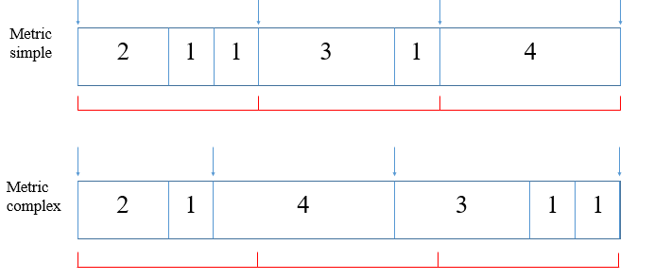
Figure 1. Schematic example of the two types of rhythmic sequence stimuli, metric simple and metric complex. Numbers represent relative length of intervals in each rhythm, where 1 = 220-270 msec (blue arrow = perceptual accent, red = beat structure)

Rhythm Discrimination. In the rhythm discrimination task, participants heard two identical presentations of the same given rhythm, followed by a third target rhythm that was either the same or different from the initial given rhythm. Participants were asked to respond whether they thought the target rhythm was the same or different, using the “s” and “d” keys on the Ergodex DX1 pad. An accurate response of “same” or “different” was considered as a correct trial. Four practice trials preceded two blocks of 30 trials each. Each block had 15 metric simple and 15 metric complex rhythms, presented in random order, for a total of 60 unique trials.
Rhythm Reproduction. For the rhythm reproduction task, participants were presented with a given rhythm, repeated three times. They were asked to tap that rhythm back, exactly as they heard it, using the “m” key on the Ergodex DX1 pad. Participants completed five practice trials before testing. Presented rhythms were either metric simple or metric complex. Additionally, rhythms were either 12 units in length or 8 units in length, where a unit was the shortest interval in the rhythm. Rhythms were presented in three blocks of 14 rhythms each – seven metric simple and seven metric complex (five 12-unit and two 8-unit rhythms each), for a total of 42 unique trials. Reproduced rhythms where all intertap intervals were within 20% of the original rhythm intervals were considered correct trials.
Procedure
Upon signing the letter of information and informed consent, participants completed the BL-VAS questionnaire, the MOCA, and a questionnaire battery of BDI-II, BAI-I, SAS. Participants completed the motor section of the MDS-UPDRS. Participants were tested individually on both a discrimination followed by a reproduction paradigm. The tasks were presented in this order because the reproduction task has an increased motor demand, which could provide challenges to PD participants. Thus, we started participants on the rhythm discrimination task first. Both tasks were completed on a laptop. Auditory stimuli were presented via noise-cancelling headphones and instructions were both verbally explained and visually presented on the laptop. Participants were asked not to hum or tap while listening to the rhythms. Two unique versions of each task were used and counterbalanced amongst participants within group. Following these two tasks, participants were debriefed and compensated for their time and participation.
Results
Statistical Analyses
Amount of correct trials for all rhythms (both metric simple and metric complex) for both rhythm discrimination and rhythm reproduction tasks were recorded and used as a measure of performance. Crawford-Howell t-tests were run to compare proportion of correct trials for each rhythm type between PD and controls, and paired t-tests were run to compare between rhythm types. In addition, d’ scores were computed for the rhythm discrimination task as an accuracy measure to account for response bias. A Crawford-Howell t-test was run to compare d’ scores for each rhythm type between PD and controls. Reproduced rhythms with the correct number of intervals (for both correct and incorrect trials) were further analyzed to compute average percent error of the intervals in each rhythm. A 2x2 (rhythm type [ms, mc] x rhythm length [12-unit, 8-unit]) repeated measures ANOVA was used to analyze average percent error on these trials for all participants. All tests determined significance at p ≤ .05.

Rhythm Discrimination
Crawford-Howell t-tests of d’ scores revealed no significant effects of group for ms rhythms, t(6) = .795, p = .457, or mc rhythms, t(6) = -.342, p = .739. Paired t-tests revealed no significant effects of rhythm type, t(7) = -.593, p = .577 (Figure 2).
Crawford-Howell t-tests of proportion of correct trials revealed no significant effects of group for metric simple (ms) rhythms, t(6) = .505, p = .638 , or metric complex (mc) rhythms, t(6) = -1.531, p = .173. Paired t-tests revealed no significant effects found for rhythm type, t(7) = .796, p = .452, on tasks of rhythm discrimination (Figure 3). These findings indicated that the PD patient demonstrated an equally accurate ability to discriminate both ms and mc rhythms.

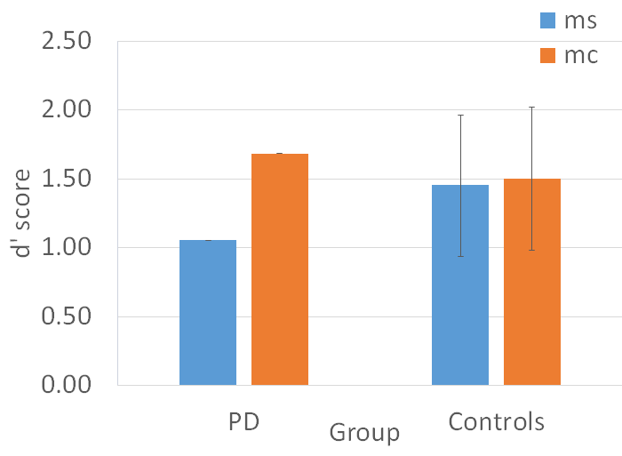
Figure 2. D’ scores for Parkinson’s Disease (M_{ms}= 1.05, M_{mc}= 1.68) and control participants (M_{ms}= 1.45, M_{mc}= 1.5) on rhythm discrimination task. No significant effects of group found for metric simple (p=.457), or metric complex rhythms (p=.739). No significant effects of rhythm type found (p=.577).

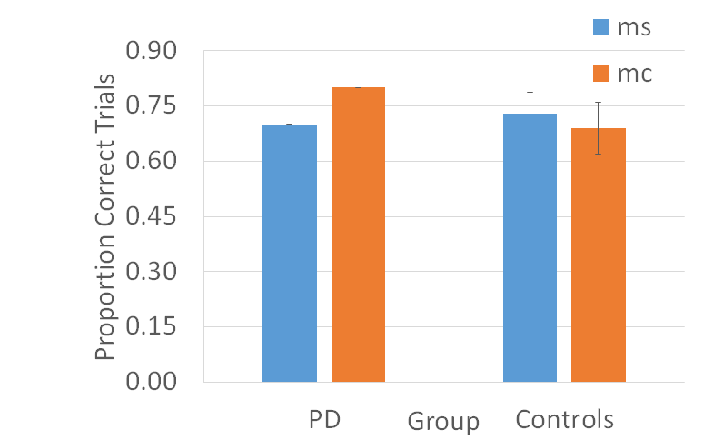

Figure 3. Proportion of correct trials for Parkinson’s Disease (M_{ms}= 0.70, M_{mc}=0.80) and control participants (M_{ms}= 0.73, M_{mc}= 0.69) on rhythm discrimination task. No significant effects of group found for metric simple (ms) rhythms (p=.638), or metric complex (mc) rhythms (p=.173). No significant effects found for rhythm type (p=.452).

Rhythm Reproduction
Crawford-Howell t-tests revealed no significant effects of group found for metric simple, t(6) = -1.201, p = .278, or metric complex rhythms, t(6) = -.621, p = .561. However, paired t-tests revealed a significant effect of rhythm type, t(7) = 3.445, p = .011 (Figure 4). This indicated that the PD patient performed similar to controls in that all participants performed better on metric simple than metric complex rhythms.
The 2x2 repeated measures ANOVA revealed a significant main effect of rhythm type, F(1, 7) = 8.665, p = .022, a significant main effect of rhythm length, F(1,7) = 12.627, p = .009, but no significant (type x length) interaction, F(1, 7) = 1.309, p = .290) (Figure 5). These findings suggested that participants were better at reproducing metric simple over metric complex rhythms, and shorter rhythms over longer rhythms.

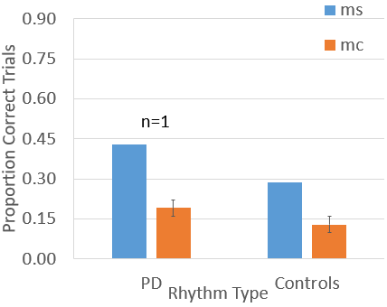
Figure 4. Proportion of correct trials for Parkinson’s Disease (M_{ms}= 0.43, M_{mc}= 0.19) and control participants (M_{ms}= 0.29, M_{mc}= 0.13) on rhythm reproduction task. No significant effects of group found for metric simple (ms) rhythms (p=.278), or metric complex (mc) rhythms (p=.561). Both groups performed better on ms rhythms than mc rhythms (p=.011).

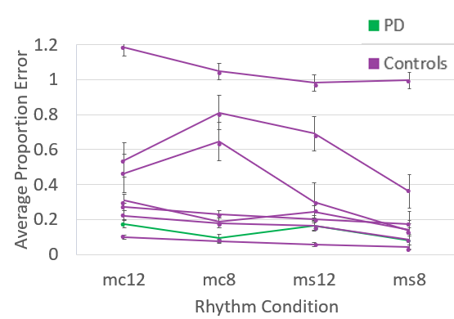
Figure 5. Single subject data for average percent error on 8- and 12-unit metric simple (ms) and metric complex (mc) rhythms. Participants performed better on ms over mc rhythms (p = .022) and rhythms with 8 units over 12 units (p = .009). No interaction effect of rhythm type x rhythm length was found (p = .290).

Discussion
The current study investigated beat perception in individuals with Parkinson’s Disease, compared to their healthy matched controls. Beat perception was scored by performance on tasks of rhythm discrimination and rhythm reproduction. Results of the current investigation revealed that, contrary to the hypothesis, PD patients did not display an impairment in beat perception. The PD group performed similar to controls in both tasks. In the rhythm discrimination task, results revealed that participants were not performing significantly different on metric simple and metric complex rhythms. However, participants performed better on metric simple than metric complex rhythms in the rhythm reproduction task. This provides mixed support for our hypothesis that metric simple rhythms are easier to remember than metric complex rhythms. Average percent error was calculated to examine the presence of a consistent effect of rhythm type across participants. Participants seemed to follow a similar trend in that metric simple rhythms were more easily reproduced than metric complex, and the shorter 8-unit rhythms were more easily reproduced than the longer 12-unit rhythms.
Interestingly, we found an effect of rhythm type in the rhythm reproduction task but not the discrimination task. The control group’s performance in the rhythm discrimination task did not differ significantly between metric simple and metric complex rhythms. This could be due to a large variability in performance in the control group, as seen by a large standard error in d’ score. This large difference could indicate that response bias in this task could be driving this variability, such that no effect of rhythm type can be discerned. As suggested in Cameron et al. (2016), the absence of an expected effect of rhythm type could also be due to a lack of validity in the rhythm discrimination task. Performance is not only dependent on beat perception, but also on the nature of the discrimination for each rhythm. Some “different trial” rhythms may have been easier to discriminate than others, depending on where in the rhythm the change occurred. Changes occurring at the beginning or end of the rhythm are subject to primacy and recency effects, and thus are easier to detect (Mondor & Morin, 2004).
Memory effects can also explain the main effect found for rhythm length. It would be expected that shorter rhythms are easier to remember and reproduce than longer rhythms, as evidenced by Povel & Essens (1985). The auditory short-term memory has a store of about 1.5-4s, (Darwin, Turvey, & Crowder, 1972; Crowder, 1982; Cowan, 1984), so it is possible that the auditory trace could have decayed in longer rhythms. Additionally, encoding a rhythm with a beat structure would allow for an increased ability to maintain its representation in auditory memory. The PD participant’s lack of impairment in rhythm reproduction could be an indication of a similar beat perception to controls, thus, a lack of beat perception impairment.
All participants in this study were kept on their normal medication schedule, and the PD participant was tested within 1-3 hours of taking their medication, during their subjective peak on-phase. Given the evidence that dopaminergic medication improves motor timing in individuals with PD, this could explain a lack of significant difference in performance between PD and controls. It is possible that PD individuals are impaired on tasks of beat perception, and that dopaminergic medication does not eliminate this impairment. Due to the limited sample size, it is impossible to distinguish how dopaminergic medication mediates beat perception in Parkinson’s Disease individuals.
Overall, results support evidence that beat-based rhythms are more easily remembered and reproduced than non-beat-based rhythms. However, these findings do not present further evidence for a beat-based timing impairment in Parkinson’s Disease. Results from this study should be taken with reservation as the sample size used was very limited. With only one PD participant, it would be difficult to confidently conclude that Parkinson’s Disease does not have a negative effect on beat perception. In addition, it is impossible to run statistical analyses on a sample of one, so within group effects of rhythm type cannot be identified. Continued data collection is required to further understanding of beat-based timing mechanisms in Parkinson’s Disease.

References

Alexander, G. E. (2004). Biology of Parkinson’s disease: pathogenesis and pathophysiology of a multisystem neurodegenerative disorder. Dialogues in Clinical Neuroscience, 6(3), 259–280.
Brochard, R., Abecasis, D., Potter, D., Ragot, R., & Drake, C. (2003). The “ticktock” of our internal clock. Psychological Science, 14, (4): 362-366. doi:10.1111/1467-9280.24441
Cameron, D. J., Pickett, K. A., Earhart, G. M., & Grahn, J. A. (2016). The effect of dopaminergic medication on beat-based auditory timing in Parkinson’s Disease. Frontiers in Neurology, 7. doi:10.3389/fneur.2016.00019
Cowan, N. (1984). On short and long auditory stores. Psychological Bulletin,96(2), 341-370. doi:10.1037//0033-2909.96.2.341
Crowder, R. G. (1982). Decay of auditory memory in vowel discrimination. Journal of Experimental Psychology: Learning, Memory, and Cognition,8(2), 153-162. doi:10.1037//0278-7393.8.2.153
Darwin, C. J., Turvey, M. T., & Crowder, R. G. (1972). An auditory analogue of the sperling partial report procedure: Evidence for brief auditory storage. Cognitive Psychology,3(2), 255-267. doi:10.1016/0010-0285(72)90007-2
Essens, P. J., & Povel, D. (1985). Metrical and nonmetrical representations of temporal patterns. Perception & Psychophysics, 37, (1): 1-7. doi:10.3758/bf03207132
Grahn, J. A., & Brett, M. (2007). Rhythm and beat perception in motor areas of the brain. Journal of Cognitive Neuroscience, 19, (5): 893-906. doi:10.1162/jocn.2007.19.5.893
Grahn, J. A., & Brett, M. (2009). Impairment of beat-based rhythm discrimination in Parkinson’s disease. Cortex, 45(1), 54-61. doi:10.1016/j.cortex.2008.01.005
Harrington, D. L., Haaland, K. Y., & Hermanowitz, N. (1998). Temporal processing in the basal ganglia. Neuropsychology,12(1), 3-12. doi:10.1037//0894-4105.12.1.3
Jahanshahi, M., Jenkins, I. H., Brown, R. G., Marsden, C. D., Passingham, R. E., & Brooks, D. J. (1995). Self-initiated versus externally triggered movements. Brain, 118, (4): 913-933. doi:10.1093/brain/118.4.913
Mondor, T. A., & Morin, S. R. (2004). Primacy, recency, and suffix effects in auditory short-term memory for pure tones: Evidence from a probe recognition paradigm. Canadian Journal of Experimental Psychology/Revue Canadienne De Psychologie Expérimentale,58(3), 206-219. doi:10.1037/h0087445
Oboyle, D. J., Freeman, J. S., & Cody, F. W. (1996). The accuracy and precision of timing of self-paced, repetitive movements in subjects with Parkinson’s disease. Brain, 119, (1): 51-70. doi:10.1093/brain/119.1.51
Patel, A. D., Iversen, J. R., Chen, Y., & Repp, B. H. (2005). The influence of metricality and modality on synchronization with a beat. Experimental Brain Research,163(2), 226-238. doi:10.1007/s00221-004-2159-8
Povel, D., & Essens, P. (1985). Perception of temporal patterns. Music Perception: An Interdisciplinary Journal,2(4), 411- 440. doi:10.2307/40285311
Thaut, M. H., Mcintosh, G. C., Prassas, S. G., & Rice, R. R. (1992). Effect of rhythmic auditory cuing on temporal stride parameters and EMG patterns in normal gait. Neurorehabilitation and Neural Repair,6(4), 185-190. doi:10.1177/136140969200600403
Thaut, M. H., Mcintosh, G. C., Rice, R. R., Miller, R. A., Rathbun, J., & Brault, J. M. (1996). Rhythmic auditory stimulation in gait training for Parkinson’s disease patients. Movement Disorders,11(2), 193-200. doi:10.1002/mds.870110213

