Effects of Cue Enjoyment and Beat Perception on Gait in Parkinson’s Disease Using Rhythmic Auditory Stimulation
Renee-Marie Ragguett
Psychology 3997F
Abstract
Difficulties with gait are considered a debilitating part of Parkinson’s disease (PD). Rhythmic auditory stimulation (RAS) has been used in those with PD to improve gait; however, there have been varying levels of success. Large differences in participant’s performance can be observed based on cue type, instruction type and unique beat perception ability. To further understand the different components contributing to the varying levels of improvement seen in RAS, we explored one component of music – enjoyment, and its relationship with instruction (i.e., to synchronize to the beat or free walk) and the beat perception abilities of the participants. Thirty participants with PD were randomly instructed to either synchronize to the beat or free walk to eight self-reported high enjoyment and low enjoyment cues and 2 metronome cues where all cues were 15% faster than the participants baseline. Each participant was classified as either a good beat perceiver or a poor beat perceiver based on their performance on the Beat Alignment Test perception task. Results indicated that enjoyment did not have an effect on gait parameters, and there were no interactions between instruction type and beat perception on gait parameters. Additionally, while significant three-way interactions were found between enjoyment, beat perception, and instruction, no significant post hocs were observed. While enjoyment does not appear to have any impact on gait performance during RAS, it may still prove to be a motivational feature in a clinical setting which could aid with adherence to RAS treatment regimens.

Introduction
Parkinson’s disease (PD) is a chronic and progressive neurological disorder affecting millions of people worldwide. PD patients present with a series of characteristic motor impairments (e.g., tremor, rigidity and bradykinesia) which are underscored by neuronal pathophysiology (DeMaagd & Philip, 2015). Specifically, a depletion of the dopamine-producing neurons in the substantia nigra disrupts motor pathways associated with the basal ganglia which negatively impacts automatic and controlled movements (Dickson, 2012; Groenewegen, 2003). Pharmaceutical treatments for PD aim to increase dopamine in the brain and often include levodopa. While levodopa has demonstrated efficacy in reducing the severity of parkinsonism, gait difficulties often persist (Curtze, Nutt, Carlson-Kuhta, Mancini, & Horak, 2015). Thus, pharmaceutical treatments can be augmented with additional treatments (e.g., physical therapy and sensory cueing) to further improve residual motor deficits (Rubinstein, Giladi, & Hausdorff, 2002).
Falls occur frequently and are a constant concern of those with PD (Bloem, Steijns, & Smits-Engelsman, 2003; Grimbergen, Schrag, Mazibrada, Borm, & Bloem, 2013). Gait variability and postural instability have been associated with increased occurrences of falls and have been reported as considerable contributors to the low quality of life scores observed in PD patients (Schrag, Jahanshahi, & Quinn, 2000). Given its association with falling, gait difficulties are a debilitating symptom of PD and have been identified as a therapeutic target. Gait patterns observed in those with PD differ from healthy controls in various ways. Normal gait is continuous and rhythmic; however, gait observed in PD can be stagnated and variable (Peterson et al., 2015). Difficulties observed in PD during straight walking include shorter stride length, increased double support time, imbalance, larger step-to-step variability, and freezing of gait (Morris, Iansek, Matyas, & Summers, 1994; Okada, Fukumoto, Takatori, Nagino, & Hiraoka, 2011; Peterson et al., 2015). Ultimately, many of these characteristics result in slower gait. There is evidence that dopaminergic treatments of PD alleviate some, but not all, of the aforementioned gait difficulties. Notably, stability and cadence have shown little, to no improvement with dopaminergic treatments (Smulders, Dale, Carlson-Kuhta, Nutt, & Horak, 2016). Evidence for improvements in gait difficulties in PD have been observed with the use of external rhythmical cueing (Lim et al., 2005).
Rhythmic auditory stimulation (RAS) is a form of external rhythmical cueing where auditory stimuli, such as music or metronome, are used to improve gait. Specifically, RAS has evoked gait improvements in various movement disorders including PD and stroke (Michael H Thaut & Abiru, 2010). RAS is suggested to facilitate improvement in movement through entrainment, which is the synchronization of rhythmic processes (i.e. an auditory beat and the stride). When administered to those with PD, RAS has been associated with increased velocity, cadence, and stride length (Michael H Thaut et al., 1996). These improvements have further been associated with decreased occurrences of falls (Moumdjian, Buhmann, Willems, Feys, & Leman, 2018; M. H. Thaut, Rice, Braun Janzen, Hurt-Thaut, & McIntosh, 2018). There are mixed reports surrounding the efficacy of auditory cues used in RAS. For example, Chester, Turnbull and Kozey (2007) used a non-musical cue and found a decrease in gait velocity following RAS; in contrast Ford, Malone, Nyikos, Yelisetty and Bickel (2010) used a musical cue and found increased gait velocity following RAS. It is possible that these differences arise as there is no standardization in auditory cues. Furthermore, whether there are optimal cues is presently unknown (Spaulding et al., 2013).
Music has many properties which can mediate its effectiveness during RAS. Groove (i.e., the compulsion to move one’s body in time with music) has been shown to have an impact on gait parameters during RAS (Leow, Parrott, & Grahn, 2014; Madison, 2006). For example, Leow et al., (2014) demonstrated in healthy controls that, when told to synchronize their walking to the beat with a low groove cue, participants’ gait was negatively affected by the cue when they had poor beat perception. Specifically, there was an increase in stride width and stride length variability. In contrast, both stride width and stride length variability were reduced with a high groove cue regardless of beat perception ability. It was suggested that low groove music was harder to synchronize to, possibly impeding gait. Neural correlates of groove have also been documented in specific populations. When listening to high-groove music, musicians showed increased corticospinal excitability in contrast to low-groove music. These correlations suggest increased motor system engagement associated with high-groove music (Stupacher, Hove, Novembre, Schutz-Bosbach, & Keller, 2013).
Music has been considered a reinforcing and enjoyable stimulus, and these characteristics may have utility for encouragement and improvements in gait difficulties. Moreover, music has been shown to enhance compliance to fitness programs (Harmon & Kravitz, 2007). Exercise intervention studies for PD such as RAS have shown low adherence (Ene, McRae, & Schenkman, 2011). Therefore, music may increase motivation and engagement to facilitate adherence to these programs (Leow, Rinchon, & Grahn, 2015). Leow et al. (2015) suggested that increased enjoyment of the music stimuli may have contributed to faster strides. However, enjoyment was not empirically tested and may have resulted from increased exposure to the stimuli as it has been documented that familiarity can mediate enjoyment (van den Bosch, Salimpoor, & Zatorre, 2013). Recently, Roberts (2017) examined the effect of enjoyment on gait in healthy controls and observed that enjoyment had no effect on this population; however, this method has not been explored in those with PD.
The ability to synchronize gait to the presented auditory stimuli depends, in part, on the individual’s ability to perceive the beat. Poor beat perception abilities may result in difficulties synchronizing (Phillips-Silver et al., 2011). Beat perception abilities vary throughout the population where strong and weak beat perceivers show different neural activation. For example, strong beat perceivers have shown increased activity in the left premotor cortex, left insula and supplementary motor area. Furthermore, the basal ganglia and supplementary motor areas, among other areas, show increased activation while listening to rhythmic tone stimuli (Grahn & McAuley, 2009). Grahn and Brett (2009) demonstrated that people with PD may have impaired beat perception by comparing PD and healthy controls on simple and complex rhythm discrimination tasks. Attempting to perceive the beat and synchronize gait in RAS may produce dual-task interference in PD patients, resulting in impairments in either task. Though the exact mechanism supporting dual-task interference in PD is unknown, it is suggested that these impairments arise from competing for attentional resources in dual tasks (e.g., a task with two different motions, or a task with a motor and cognitive component) where divided attention is required (Wu & Hallett, 2008). This has been explored in relation to gait in PD wherein gait difficulties were increased when attention was divided with the completion of a complex task while walking (Bond & Morris, 2000). Thus, in addition to an optimal stimulus for RAS, there may be optimal task directions (e.g., to synchronize to the beat or to free walk) dependent on the individual’s ability to perceive the beat.
The present study adds to previous literature by using self-reported enjoyable and unenjoyable music with high groove as an auditory cue for RAS in patients with PD. It is hypothesized that music with high enjoyment and high groove would elicit improvements in gait as measured by increased velocity, increased cadence, longer stride length, reduced stride width, and reduced double-limb support time. This has been explored in young and old healthy adults, and no significant differences were observed for enjoyable music (Roberts, 2017). However, this paradigm has not been tested in PD and an enjoyable stimuli may prove to motivate PD patients to move at an increased velocity (Shiner et al., 2012). Furthermore, we aim to explore the importance of instructions to synchronize during RAS by randomizing participants to either synchronize (match the beat) or free-walk (walk comfortably). It is hypothesized that when told to free walk, poor beat perceivers would demonstrate greater improvements in gait, in comparison to poor beat perceivers told to synchronize. Instructing poor beat perceivers to free walk may prove to be beneficial as there may be less dual-task interference from trying to synchronize gait to the beat of an auditory cue. Furthermore, it is hypothesized that maximum improvements in gait parameters would be observed with high enjoyment cues for both poor beat perceivers told to free walk and strong beat perceivers told to synchronize.
Method
Participants
The sample was composed of 30 participants with PD who were recruited from a database of registrants from events by the Parkinson’s Society of Southwestern Ontario. Recruitment exclusion criteria included those who required assistance walking (e.g., the use of a cane or other walking devices). Furthermore, participants were excluded from the data analysis if they were unable to walk on the mat properly (i.e., did not walk within the active sensor area of the mat) (view Figure 1 for mat dimensions). Additionally, participants were excluded if they did not complete at minimum 77% of the trials per condition (i.e., high enjoyment stimuli and low enjoyment stimuli). Two participants were excluded in the data analysis on the basis of the exclusion criteria, specifically both participants failed to complete the minimum number of trials. Therefore, the final sample for analysis was composed of 28 participants. Participants were tested individually in the gait laboratory and were randomized to one of two instruction conditions: (1) free walking or (2) synchronized. Participants were further classified as good or poor beat perceivers using the perception task of the Beat Alignment Test. Good beat perceivers are considered those who scored above the median and poor beat perceivers are those who scored below the median (median = 0.59). Participants completed the experiment during peak on-phase of their medication cycle as determined by a pre-screening questionnaire. Participants were compensated $5 per half hour.
Materials
Beat Alignment Test. The Beat Alignment test (BAT) from the Goldsmiths Music Sophistication Index was used to measure beat perception and beat production abilities (Miyazaki, Hiraga, Adachi, Nakajima, & Tsuzaki, 2008; Müllensiefen, Gingras, Stewart, & Musil, 2012). The BAT was administered using E-Prime on a laptop computer. To measure beat perception independently of motor production ability, participants listened to 17 music excerpts with a superimposed beep-track and judged if beeps were on or off the beat. Specifically, there were 4 trials with no error, 5 trials with a phase error where the beep is ahead of the beat, and 8 trials with a period error where the beep is faster or slower than the beat. When the participant made their decision, they were to press the space bar. Following the end of the excerpt, the participant indicated their choice by selecting the ‘Y’ key for on beat and the “N” key for off beat. Participants also rated their confidence using a 1 (guessing), 2 (somewhat sure) or 3 (completely certain). To measure beat production, participants tapped to the beat of 12 music excerpts using the space bar. Following the excerpts participants rated their familiarity with the clip using a 1 (never heard it), 2 (somewhat familiar), or 3 (very familiar).
Demographics and Music Training Questionnaire. A questionnaire collecting demographics information, music and dance training information used previously in a similar study, was administered in the current study (Roberts, 2017). Demographic questions addressed included age, gender and handedness (see Appendix A for the full questionnaire). The music and dance training section were comprised of items regarding musical experience (e.g., “do you have any formal music training” and “do you have any formal dance training”) (see Appendix A for the full questionnaire).
Movement Disorder Society Unified Parkinson’s Disease Rating Scale Part III. Part III of the Movement Disorder Society Unified Parkinson’s Disease Rating Scale (MDS-UPDRS) served as a motor examination assessing the motor components of PD (Goetz et al., 2008). The MDS-UPDRS is composed of 18 items regarding motor presentations of PD (e.g., constancy of rest tremor rated on a scale of 0 (normal) to 4 (severe)).
Rating Task. Participants rated 32 song excerpts (instrumental versions, 10 seconds each); individual ratings were used to select stimuli for gait tasks (see ‘Stimuli’). Participants rated the excepts on 4 measures. (1) Familiarity, “how familiar are you with this piece of music?” on a scale of 1 (never heard it before) to 100 (I have heard this song multiple times before and can predict what happens next). (2) Groove, “how much does this piece of music make you want to move to it?” on a scale of 1 (no desire to move) to 100 (strong desire to move). (3) Enjoyment, “how much do you enjoy this piece of music?” on a scale of 1 (strongly dislike) to 100 (strongly like) and (4) beat salience, “how strong is the beat in this piece of music?” from 1 (very weak) to 100 (very strong).
Stimuli. Thirty-two songs of various genres (see Appendix B for stimuli details) and a metronome were modified using Audacity (http://audacity.sourcefourge.net) to a tempo (beats per minute) 15% faster than the participant’s baseline cadence (steps per minute). Pitch was unaltered. Cue pace of +15% has been used in previous research finding improvements in gait velocity and cadence (Cha, Kim, & Chung, 2014; Leow et al., 2015; Roberts, 2017). All auditory stimuli were presented at maximum headphone (Sennheiser HDR 160) volume and computer volume of 20; however, the participant could adjust the volume to their preference for comfort.
Selection of stimuli for gait task. A MATLAB script was used to select eight songs rated at high enjoyment and eight songs rated at low enjoyment with both rated as low familiarity. Low familiarity was operationalized as subjective familiarity less than or equal to 50 on the rating task if the median familiarity of all songs were less than or equal to 50. Alternatively, if the median familiarity was greater than 50, low familiarity songs were considered as those less than or equal to the median of familiarity plus 10. Eight songs rated highest and lowest in enjoyment were initially selected. These initial lists had their mean groove ratings compared using a t-test, such that if they were found to be different (p < .05) up to two song substitutions were made with songs of low or high enjoyment respectively to reduce the mean difference in groove.
Procedure
Participants received a letter of information and provided informed consent upon arriving at the lab. Participants then completed the perception portion of the BAT. The accuracy score achieved on the BAT perception was then used to place the participants in either the good beat perceivers or poor beat perceivers group using a median split. Following the demographics questionnaire, the UPDRS-III was administered to patients by the experimenter. Participants completed a baseline (silent/un-cued) walk on a 16 foot pressure sensitive walkway (Zeno, Protokinetics Inc.). Participants were instructed to complete 8 consecutive passes of the walkway (8 passes = 1 trial). To remain in constant motion and reduce acceleration/deceleration effects, participants walked to floor markings 1.78m from each edge of the walkway before completing a loop to turn and re-enter the mat (see Figure 1 for a graphical depiction of the walkway). Participants then completed the production portion of the BAT. Concurrently, the experimenter calculated the participant’s baseline cadence and the +15% tempo for stimuli. Participants completed the rating task followed by 20 cued gait trials (2 practice, 18 experimental). Cued gait trials followed the same procedure as un-cued (8 consecutive passes of walkway). However, participants were instructed to either match footsteps with the beat (synchronized condition) or walk comfortably with music in the background (free-walking condition) based on pre-randomization. Two practice trials prior to experimental trials provided participants opportunity to practice the assigned walking style and to ask questions. Stimuli were played over speakers for practice trials and over wireless headphones (Sennheisser HDR 160) for experimental trials. Stimuli order (16 songs, 2 metronome) was randomized for each participant. Two additional silent trials (identical to baseline – no songs, no synchronization instruction) were performed after the 8th cued walk and the 18th (final) cued walk. Participants then completed the music/dance training questionnaire and were debriefed. The full procedure can be seen in Figure 2.
Data Analysis
The BAT perception was used to determine good and poor beat perceivers wherein those above the median were placed in the good beat perceivers group and those who scored below the median were placed in the poor beat perceivers group. The score used to determine the selection was an average accuracy score between 0 and 1, where 0 was all incorrect and 1 was all correct.
Proportion change scores were used to determine the change in spatiotemporal gait parameters from baseline. Proportion change score = $\frac{gait parameter-baseline gait parameter}{baseline gait parameter}$. ProtoKinetics Movement Analysis Software (PKMAS) was used to process all walking trials as PKMAS generates various gait parameters (e.g., stride length, stride width and cadence). An 3x2x2 analysis of variance (ANOVA) was used to test the differences between cue enjoyment (3 levels: high enjoyment, low enjoyment, and metronome), beat perception ability (2 levels: poor beat perceivers and good beat perceivers) and instruction type (2 levels: synchronize and free walk) on each gait parameter of interest. All within subject measures were reported using the Greenhouse-Geisser correction, which corrects for violations of the assumption of sphericity.
Results
Participant Demographics
Participants varied in age from 55 years to 91 years (M = 68.61, SD = 9.02), and were 71.4% male (males N = 20, females N = 8). The minimum UPDRS modified Hoehn Yarh scale score was 1 and the maximum score was 4 (M = 2.75, SD = 1.00). Twenty three percent of participants reported abnormal hearing; however, 50% of those who reported abnormal hearing self-reported the use of hearing aids. Half of the participants had formal music training which ranged in duration from one year of formal training to 60 years (M = 8.7, SD = 18.07). Fourteen percent (14.29%) of participants had formal dance training which ranged in duration from three years to five years (M = 3.67, SD = 1.15). Table 1 further outlines participant demographics by condition type.

Beat Alignment Test – Perception
The accuracy scores on the BAT perception ranged from 0.35 to 0.94 (M = 0.64, SD = 0.16, median = 0.59). An independent sample t-test revealed that the mean of the BAT perception scores were found to be significantly different between the poor beat perceivers (M = 0.51, SD = 0.09) and the good beat perceivers (M = 0.77, SD = 0.10; t(26) = 7.36, p < .001). Furthermore, it was found that years of formal music and/or dance training did not differ between those in the poor beat perceivers group (M = 4.86, SD = 15.93) and those in the good beat perceivers group (M = 1.57, SD = 2.03; t(26) = -0.77, p = .451). Using a bivariate correlation, no correlation was found between years of formal music/dance training and BAT perception score (r = -.014, p =.942). As no correlation was found, the following analyses do not include an ANCOVA using years of formal music/dance training as a covariate. BAT perception scores, music and dance training proportions are further outlined in Table 1 by condition type.
Stimuli Ratings
An independent sample t-test was used to assess the differences between participant’s ratings on the high enjoyment stimuli and the low enjoyment stimuli. Levene’s tests for homogeneity of variances was significant for all t-tests, thus all statistics were reported with equal variances not assumed. The familiarity rating for high enjoyment stimuli (M = 24.57, SD = 24.48) differed significantly from the low enjoyment stimuli (M = 10.81, SD = 17.62; t(366.56) = 6.45, p < .001). The groove rating for high enjoyment stimuli (M = 46.51, SD = 25.04) differed significantly from the low enjoyment stimuli (M = 17.37, SD = 18.54; t(366.81) = 13.23, p < .001). The enjoyment rating for high enjoyment stimuli (M = 51.36, SD = 24.09) differed significantly from the low enjoyment stimuli (M = 13.85, SD = 17.34; t(361.51) = 17.88, p < .001). The beat salience rating for high enjoyment stimuli (M = 65.81, SD = 25.44) differed significantly from the low enjoyment stimuli (M = 41.63, SD = 31.62; t(380.56) = 8.43, p < .001).
Gait Measures
Stride Length. A significant main effect of beat perception was observed with respect to stride length between participants (F(1, 24) = 5.46, p = .028, ɳ_{p}² = .19, power = .611) indicating that stride length shortened more for good beat perceivers (M = -0.0176, SD = 0.0313) compared to poor beat perceivers (M = -0.0002, SD = 0.0591). These changes in stride length during RAS trials (M = 120.52, SD = 3.42) were significantly different from baseline (M = 122.86, SD = 11.26; t(13) = -2.47, p = .028) for those with good beat perception. However, the changes observed for those with poor beat perception were not significantly different from baseline. No significant main effect was found for instruction type and no significant interaction between instruction type and beat perception was found.
A significant three-way interaction was found between stimuli type, beat perception, and instruction type with respect to stride length within participants (F(1.65, 39.62) = 3.56, p = .046, ɳ_{p}² = .13, power = .574). A follow up two-way ANOVA wherein beat perception was held constant, revealed that the interaction was being driven by participants with good beat perception (F(1.83, 21.99) = 4.51, p = .025, ɳ_{p}² = .27, power = .685). However, a post hoc Tukey-HSD revealed that there were no significant differences. No main effects of stimuli or two-way interactions between stimuli and beat perception or stimuli and instruction were found. View Figure 3 for a graphical depiction of stride length across all conditions.
Stride Velocity. A significant main effect of beat perception was observed with respect to stride velocity between participants (F(1, 24) = 11.11, p = .003, ɳ_{p}² = .02, power = .476), indicating that stride velocity increased more for poor beat perceivers (M = 0.037, SD = 0.072) compared to good beat perceivers (M = -0.005, SD = 0.042). The changes observed for good beat perceivers were not significantly different from baseline; however, the differences in stride velocity observed for poor beat perceivers (M = 91.67, SD = 27.97) was significantly different from baseline (M = 87.79, SD = 26.23; t(13) = -3.11, p = .008). No significant main effects were found for instruction type, and no significant interactions between instruction type and beat perception were found.
A main effect of stimuli type was found within participants for stride velocity (F(1.98, 47.44) = 4.11, p = .023, ɳ_{p}² = .15, power = .698). Follow up paired t-tests revealed that stride velocity differed specifically between the high enjoyment cue (M = 0.0314, SD = 0.0356) and the low enjoyment cue (M = 0.0945, SD = 0.0915; t(27) = -2.37, p = .025). The differences observed did not differ significantly from baseline.
In addition, a three-way interaction was found within participants between stimuli type, beat perception, and instruction type within subjects with respect to stride velocity (F(1.98, 47.44) = 4.39, p = .018, ɳ_{p}² = .16, power = .727). A follow up two-way ANOVA wherein beat perception was held constant, revealed that the interaction was being driven by beat perception wherein there was an interaction between stimuli and instruction type for those with good beat perception (F(1.75, 24) = 4.64, p = .025, ɳ_{p}² = .28, power = .683) and poor beat perception (F(1.88, 24) = 4.09, p = .033, ɳ_{p}² = .25, power = .649). However, a post hoc Tukey HSD revealed that there were no significant differences between the means. As a significant interaction was found, the main effect of stimuli type should be interpreted with caution. No two-way interactions were found between stimuli and instruction or stimuli and beat perception. View Figure 3 for a graphical depiction of stride velocity across all conditions.
Stride Width. No significant main effects were observed between participants for beat perception or instruction type and no significant interactions were observed.
A significant interaction between stimuli and beat perception was found for stride width within participants, (F(1.61, 38.57) = 4.97, p = .017, ɳ_{p}² = .17, power = .717). A post hoc Tukey-HSD revealed, for those with good beat perception, stride width was significantly different during high enjoyment (M = 0.0016, SD = 0.1097) compared to metronome (M = -0.0628, SD = 0.1165; F(2, 14) = 3.68, p < .05). Furthermore, stride width was also found to be significantly different between low enjoyment (M = -0.0064, SD = 0.0970) and metronome (F(2, 14) = 3.22, p < .05). None of these changes were significantly different from baseline. A post hoc Tukey-HSD on participants with poor beat perception showed that their stride width did not differ across stimuli. No significant two-way interactions were observed between stimuli and instruction, and no three-way interactions between stimuli, instruction and beat perception were found. View Figure 3 for a graphical depiction of stride width across all conditions.
Cadence. No significant main effects between subjects were observed for beat perception or instruction type and no significant interactions between beat perception and instruction type were observed.
A significant main effect of stimuli was found with relation to cadence within participants (F(1.87, 45.03) = 6.75, p = .003, ɳ_{p}² = .22, power = .886). Follow up t-test revealed that cadence differed specifically between the high enjoyment cue (M = 0.0041, SD = 0.0630) and the low enjoyment cue (M = 0.0215, SD = 0.0568; t(27) = -2.30, p = .030) and between the high enjoyment cue and the metronome (M = 0.0271, SD = 0.0557; t(27) = 3.10, p = .005). Only the cadence observed with the metronome (M = 111.58, SD = 10.34) was significantly different from baseline (M = 108.75, SD = 9.78; t(27) = 2.61, p = .015).
A significant interaction between stimuli and instruction type was found with relation to cadence within participants (F(1.87, 45.03) = 3.97, p = .028, ɳ_{p}² = .14, power = .665). A post hoc Tukey-HSD revealed, for those who received the instruction to synchronize, cadence at high enjoyment (M = 0.0093, SD = 0.0880) differed significantly from metronome (M = 0.0534, SD = 0.0666; F(2, 13) = 4.45, p < .01), these changes however did not differ significantly from baseline. No differences in cadence were found with those who received the instruction to free walk. As an interaction was significant, the main effects should be interpreted with caution. Furthermore, no other two-way interactions between stimuli and beat perception or three-way interactions between stimuli, instruction and beat perception were found. View Figure 3 for a graphical depiction of cadence across all conditions.
Double-Limb Support Time. No significant main effects were observed for beat perception or instruction type and no significant interaction for beat perception and instruction type was observed between participants.
A significant two-way interaction between stimuli and beat perception was found within participants with relation to double support time (F(1.69, 40.48) = 4.14, p = .029, ɳ_{p}² = .15, power = .650). A post hoc Tukey-HSD revealed that there were no differences between double-limb support time with respect to good beat perceivers or poor beat perceivers.
A three-way interaction between stimuli, instruction type and beat perception was found with relation to double support time (F(1.69, 40.48) = 4.25, p = .029, ɳ_{p}² = .15, power = .661). A follow up two-way ANOVA wherein beat perception was held constant, revealed that the interaction was being driven by participants with poor beat perception wherein there was a two way interaction between stimuli and instruction type (F(1.54, 18.53) = 4.18, p = .040, ɳ_{p}² = .26, power = .594). A post hoc Tukey-HSD showed that there were no significant differences between means for any combination of stimuli and instruction type. There were no main effects of stimuli observed, or two-way interactions between stimuli and instruction. View Figure 3 for a graphical depiction of double-limb support time across all conditions.
Discussion
The objective of the current study was to examine if self-reported enjoyment of an auditory cue, and the instruction given to participants during RAS may function to affect gait patterns in those with PD.
Enjoyment
Contrary to our hypothesis, the self-reported high enjoyment of a cue did not improve all gait measures of interest. However, improvements were observed in a limited number of measures. Specifically, both stride velocity and cadence increased with a high enjoyment cue, though these changes were not significantly different from baseline. These results are in accordance with a previous study that found enjoyment of RAS cues did not impact gait in younger and older healthy adults (Roberts, 2017). As participants neither experienced an increase nor decrease in gait parameters alongside auditory cues of different enjoyments, it is possible that enjoyment of cues does not need to be under consideration when choosing stimuli for RAS. Alternatively, we found that the self-reported enjoyment level between the high and low enjoyment cues were largely different, similarly to Roberts (2017). It is however, possible that the differences were not large enough to elicit changes in gait.
Outside of our hypotheses, two sets of interactions were observed. There were interactions between enjoyment and instruction for cadence and enjoyment and beat perception for stride width. While both measures had significant differences in change score, neither of the differences observed were different from baseline. These observations are not surprising as we found no other measures which had differences significant from baseline for enjoyment.
Instruction Type and Beat Perception Interaction
Contrary to our hypothesis, no instruction type and beat perception interactions were observed. These results were consistent with Roberts (2017) who also found that there were no interactions between beat perception and instruction type during RAS for younger or older healthy adults. While, our results are consistent with Roberts (2017), this was particularly surprising as is it well known that those with PD are subject to gait difficulties associated with dual-task interference (Bond & Morris, 2000). Indeed, the literature has shown that those who have PD and whom are poor beat perceivers have heightened gait problems when told to synchronize to RAS cues (Cochen De Cock et al., 2018). It is possible that we did not see this effect in our sample as we may have been under powered. Alternatively, the classification used to divide participants into poor and good beat perceivers may not represent beat perception abilities well. Others in the literature who have identified differences in RAS between poor and good beat perceivers have used both the BAT, the Battery for the Assessment of Auditory Sensorimotor and Timing Abilities, and the Goldsmiths Musical Sophistication Index as a proxy of good beat perception and musicality (Cochen De Cock et al., 2018).
Notably, changes that were significantly different from baseline were observed in stride length and stride velocity dependent on beat perception ability regardless of instruction type. Specifically, there was a significant shortening of stride with RAS for those with good beat perception abilities and an increase in stride velocity with RAS for those with poor beat perception abilities. Shortening of strides in good beat perceivers was also observed by Ready, McGarry, Rinchon, Holmes, and Grahn (2019) and was suggested to occur possibly due to specific characteristics of the auditory cue that were not beat related (e.g., groove). Furthermore, an increase in stride velocity for those with poor beat perception regardless of instruction has not been observed in the literature. It is possible that this increase could also be to do a non-beat related characteristic of the auditory cue.
Interaction Between Enjoyment, Instruction Type and Beat Perception
Multiple gait measures (i.e., stride length, stride velocity, and double-limb support time) had three-way interactions between enjoyment, instruction type and beat perception ability. However, for all three-way interactions, post hoc analyses revealed that there were no significant differences. These results were inconsistent with our hypotheses, however consistent with the literature seen in young and older healthy adults (Roberts, 2017). As we have demonstrated that enjoyment of a stimuli does not impact gait measures in the current study, it is not surprising that the three-way interactions between enjoyment, instruction type and beat perception ability have no significant findings at this time.
Limitations and Future Directions
While we attempted to minimize differences in groove between the high enjoyment and low enjoyment cues, we were ultimately unsuccessful, such that low enjoyment cues were rated lower in groove when compared to high enjoyment cues. This may have influenced the results as previous literature has demonstrated that groove could impact gait under certain instruction conditions (Leow et al., 2014; Ready, McGarry, Rinchon, Holmes, & Grahn, 2019). Furthermore, while we did not attempt to control for beat salience differences between the high enjoyment and low enjoyment cues these were also found to be significantly different. Specifically, low enjoyment cues were lower in beat salience when compared to high enjoyment cues. This could have also impacted the results as differences observed could be due to confounding variables. While it is difficult to separate high groove from beat salience as they are associated, future studies should aim to both better control for differences in groove across enjoyment conditions and also consider controlling for beat salience in order to more narrowly target the enjoyment manipulation (Madison, 2006).
As we found no correlation between formal music/dance training and beat perception we did not include a covariate in our model. However, the literature suggests that those with PD who have musical training and good beat perception may benefit more from RAS, in contrast to those with poor beat perception who may perform deleteriously (Cochen De Cock et al., 2018). Future studies should aim to classify beat perceivers over various levels including components such as expertise (e.g., in music or dance) and training style (e.g., percussive or non-percussive) as these elements may differentially affect beat processing abilities (Nguyen, 2017).
Conclusion
The purpose of the current study was to explore the effect of enjoyment of an auditory cue and instruction type on gait performance in RAS. It was found that the self-reported level of enjoyment of a cue did not affect gait parameter. No interactions with instruction type and beat perception were found. Furthermore, no three-way interactions between enjoyment, instruction type and beat perception were found to be significant following post hocs. These results suggest that enjoyment may not be an important characteristic to consider when choosing stimuli for RAS. However, enjoyment of the stimuli may help to enhance compliance to programs such as RAS as music overall has been found to enhance compliance to fitness programs (Harmon & Kravitz, 2007).

References
Bloem, B. R., Steijns, J. A., & Smits-Engelsman, B. C. (2003). An update on falls. Current Opinions on Neurology, 16(1), 15-26. doi: 10.1097/01.wco.0000053580.70044.70
Bond, J. M., & Morris, M. (2000). Goal-directed secondary motor tasks: their effects on gait in subjects with Parkinson disease. Archives of Physical Medicine and Rehabilitation
81(1), 110-116.
Cha, Y., Kim, Y., & Chung, Y. (2014). Immediate effects of rhythmic auditory stimulation with tempo changes on gait in stroke patients. Journal of Physical Therapy Science
26(4), 479-482. doi: 10.1589/jpts.26.479
Chester, E. L., Turnbull, G. I., & Kozey, J. (2006). The effect of auditory cues on gait at different stages of parkinson's disease and during “on”/“off” fluctuations: a preliminary study. Topics in Geriatric Rehabilitation, 22(2), 187-195.
Cochen De Cock, V., Dotov, D. G., Ihalainen, P., Begel, V., Galtier, F., Lebrun, C., Dalla Bella, S. (2018). Rhythmic abilities and musical training in Parkinson's disease: do they help? NPJ Parkinsons Disease, 4, 8. doi: 10.1038/s41531-018-0043-7
Curtze, C., Nutt, J. G., Carlson-Kuhta, P., Mancini, M., & Horak, F. B. (2015). Levodopa Is a Double-Edged Sword for Balance and Gait in People With Parkinson's Disease. Movement Disorders, 30(10), 1361-1370. doi: 10.1002/mds.26269
DeMaagd, G., & Philip, A. (2015). Parkinson's Disease and Its Management: Part 1: Disease Entity, Risk Factors, Pathophysiology, Clinical Presentation, and Diagnosis. Pharmacy and Therapeutics, 40(8), 504-532.
Dickson, D. W. (2012). Parkinson's disease and parkinsonism: neuropathology. Cold Spring Harb Perspectives in Medicine, 2(8). doi: 10.1101/cshperspect.a009258
Ene, H., McRae, C., & Schenkman, M. (2011). Attitudes toward exercise following participation in an exercise intervention study. Journal of Neurologic Physical Therapy, 35(1), 34-40. doi: 10.1097/NPT.0b013e31820cb917
Ford, M. P., Malone, L. A., Nyikos, I., Yelisetty, R., & Bickel, C. S. (2010). Gait training with progressive external auditory cueing in persons with Parkinson's disease. Archives of Physical Medecine and Rehabilitation, 91(8), 1255-1261. doi: 10.1016/j.apmr.2010.04.012
Goetz, C. G., Tilley, B. C., Shaftman, S. R., Stebbins, G. T., Fahn, S., Martinez‐Martin, P., Dodel, R. (2008). Movement Disorder Society‐sponsored revision of the Unified Parkinson's Disease Rating Scale (MDS‐UPDRS): scale presentation and clinimetric testing results. Movement Disorders, 23(15), 2129-2170. doi: 10.1002/mds.21198
Grahn, J. A., & Brett, M. (2009). Impairment of beat-based rhythm discrimination in Parkinson's disease. Cortex, 45(1), 54-61. doi: 10.1016/j.cortex.2008.01.005
Grahn, J. A., & McAuley, J. D. (2009). Neural bases of individual differences in beat perception. Neuroimage, 47(4), 1894-1903. doi: 10.1016/j.neuroimage.2009.04.039
Grimbergen, Y. A., Schrag, A., Mazibrada, G., Borm, G. F., & Bloem, B. R. (2013). Impact of falls and fear of falling on health-related quality of life in patients with Parkinson's disease. Journal of Parkinsons Disease, 3(3), 409-413. doi: 10.3233/JPD-120113
Groenewegen, H. J. (2003). The basal ganglia and motor control. Neural Plastiscity, 10(1-2), 107-120. doi: 10.1155/NP.2003.107
Harmon, N. M., & Kravitz, L. (2007). The effects of music on exercise. IDEA fitness Journal, 4(8), 72-77.
Leow, L. A., Parrott, T., & Grahn, J. A. (2014). Individual differences in beat perception affect gait responses to low- and high-groove music. Frontiers in Human Neuroscience, 8, 811. doi: 10.3389/fnhum.2014.00811
Leow, L. A., Rinchon, C., & Grahn, J. (2015). Familiarity with music increases walking speed in rhythmic auditory cuing. Annals of New York Academy of Science, 1337, 53-61. doi: 10.1111/nyas.12658
Lim, I., van Wegen, E., de Goede, C., Deutekom, M., Nieuwboer, A., Willems, A., Jones, D., Rochester, L., Kwakkel, G. (2005). Effects of external rhythmical cueing on gait in patients with Parkinson's disease: a systematic review. Clin Rehabilitation, 19(7), 695-713. doi: 10.1191/0269215505cr906oa
Madison, G. (2006). Experiencing groove induced by music: consistency and phenomenology. Music Perception: An Interdisciplinary Journal, 24(2), 201-208. doi: 10.1525/mp.2006.24.2.201
Miyazaki, K. i., Hiraga, Y., Adachi, M., Nakajima, Y., & Tsuzaki, M. (2008). The Beat Alignment Test (BAT): Surveying beat processing abilities in the general population. Proceedings of the 10th International Conference on Music Perception and Cognition. Sapporo, Japan.
Morris, M. E., Iansek, R., Matyas, T. A., & Summers, J. J. (1994). The pathogenesis of gait hypokinesia in Parkinson's disease. Brain, 117 ( Pt 5), 1169-1181. doi: 10.1093/brain/117.5.1169
Moumdjian, L., Buhmann, J., Willems, I., Feys, P., & Leman, M. (2018). Entrainment and Synchronization to Auditory Stimuli During Walking in Healthy and Neurological Populations: A Methodological Systematic Review. Frontiers in Human Neuroscience, 12, 263. doi: 10.3389/fnhum.2018.00263
Müllensiefen, D., Gingras, B., Stewart, L., & Musil, J. J. (2012). Goldsmiths Musical Sophistication Index (Gold-MSI) v1. 0: Technical Report and Documentation. London: Goldsmiths, University of London.
Nguyen, T. (2017). Examining the Differences in Beat Perception and Production Between Musicians and Dancers. University of Western Ontario, Electronic Thesis and Dissertation Repository. (4913).
Okada, Y., Fukumoto, T., Takatori, K., Nagino, K., & Hiraoka, K. (2011). Abnormalities of the first three steps of gait initiation in patients with Parkinson's disease with freezing of gait. Parkinson’s Disease, 2011. doi: 10.4061/2011/202937
Peterson, D. S., Fling, B. W., Mancini, M., Cohen, R. G., Nutt, J. G., & Horak, F. B. (2015). Dual-task interference and brain structural connectivity in people with Parkinson's disease who freeze. Journal of Neurology, Neurosurgery, and Psychiatry
86(7), 786-792. doi: 10.1136/jnnp-2014-308840
Phillips-Silver, J., Toiviainen, P., Gosselin, N., Piche, O., Nozaradan, S., Palmer, C., & Peretz, I. (2011). Born to dance but beat deaf: a new form of congenital amusia. Neuropsychologia, 49(5), 961-969. doi: 10.1016/j.neuropsychologia.2011.02.002
Ready, E. A., McGarry, L. M., Rinchon, C., Holmes, J. D., & Grahn, J. A. (2019). Beat perception ability and instructions to synchronize influence gait when walking to music-based auditory cues. Gait Posture, 68, 555-561. doi: 10.1016/j.gaitpost.2018.12.038
Roberts, B. S. (2017). Comparing the influence of music enjoyment and beat perception ability on spatiotemporal gait parameters among healthy young and older adults. University of Western Ontario, Electronic Thesis and Dissertation Repository. (4893).
Rubinstein, T. C., Giladi, N., & Hausdorff, J. M. (2002). The power of cueing to circumvent dopamine deficits: a review of physical therapy treatment of gait disturbances in Parkinson's disease. Movement Disorders, 17(6), 1148-1160. doi: 10.1002/mds.10259
Schrag, A., Jahanshahi, M., & Quinn, N. (2000). What contributes to quality of life in patients with Parkinson's disease? Journal of Neurology and Neurosurgical Psychiatry, 69(3), 308-312. doi: 10.1136/jnnp.69.3.308
Shiner, T., Seymour, B., Symmonds, M., Dayan, P., Bhatia, K. P., & Dolan, R. J. (2012). The effect of motivation on movement: a study of bradykinesia in Parkinson's disease. PLoS One, 7(10), e47138. doi: 10.1371/journal.pone.0047138
Smulders, K., Dale, M. L., Carlson-Kuhta, P., Nutt, J. G., & Horak, F. B. (2016). Pharmacological treatment in Parkinson's disease: Effects on gait. Parkinsonism and Related Disorders, 31, 3-13. doi: 10.1016/j.parkreldis.2016.07.006
Spaulding, S. J., Barber, B., Colby, M., Cormack, B., Mick, T., & Jenkins, M. E. (2013). Cueing
and gait improvement among people with Parkinson's disease: a meta-analysis. Archives of Physical Medicine and Rehabilitation 94(3), 562-570. doi:10.1016/j.apmr.2012.10.026
Stupacher, J., Hove, M. J., Novembre, G., Schutz-Bosbach, S., & Keller, P. E. (2013). Musical groove modulates motor cortex excitability: a TMS investigation. Brain and Cognition, 82(2), 127-136. doi: 10.1016/j.bandc.2013.03.003
Thaut, M. H., & Abiru, M. (2010). Rhythmic auditory stimulation in rehabilitation of movement disorders: a review of current research. Music Perception: An Interdisciplinary Journal, 27(4), 263-269. doi: 10.1525/mp.2010.27.4.263
Thaut, M. H., McIntosh, G. C., Rice, R. R., Miller, R. A., Rathbun, J., & Brault, J. (1996). Rhythmic auditory stimulation in gait training for Parkinson's disease patients. Movement Disorders, 11(2), 193-200. doi: 10.1002/mds.870110213
Thaut, M. H., Rice, R. R., Braun Janzen, T., Hurt-Thaut, C. P., & McIntosh, G. C. (2018). Rhythmic auditory stimulation for reduction of falls in Parkinson's disease: a randomized controlled study. Clinical Rehabilitation, 269215518788615. doi: 10.1177/0269215518788615
van den Bosch, I., Salimpoor, V. N., & Zatorre, R. J. (2013). Familiarity mediates the relationship between emotional arousal and pleasure during music listening. Frontiers in Human Neuroscience, 7, 534. doi: 10.3389/fnhum.2013.00534
Wu, T., & Hallett, M. (2008). Neural correlates of dual task performance in patients with Parkinson's disease. Journal of Neurology, Neurosurgery, and Psychiatry
79(7), 760-766. doi: 10.1136/jnnp.2007.126599

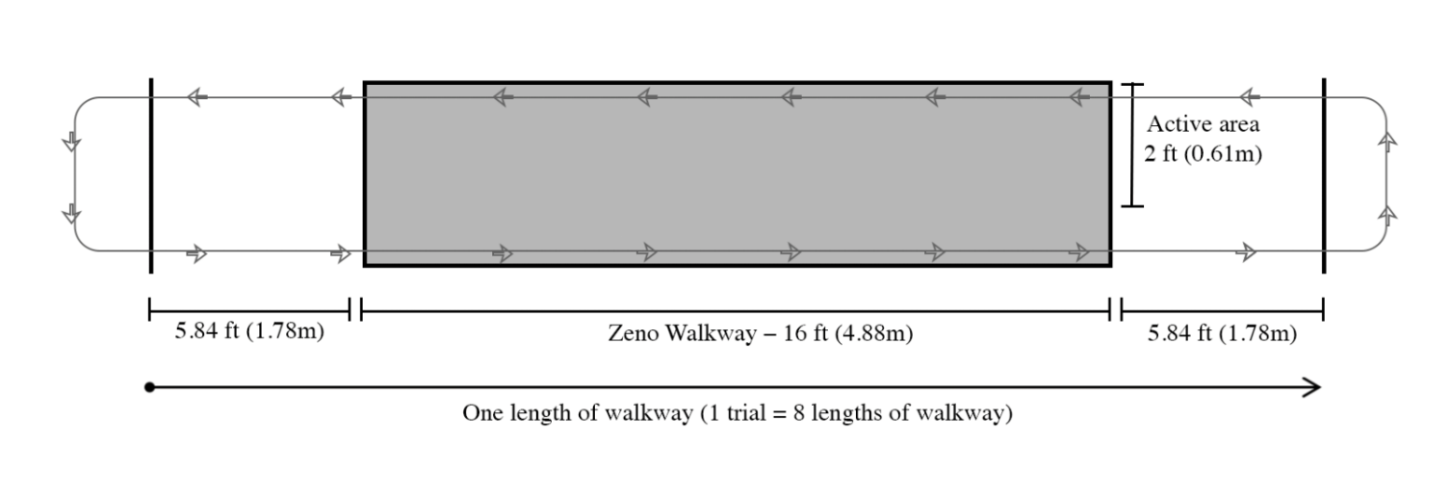
Figure 1. Dimensions and layout of Zeno walkway and gait testing area.

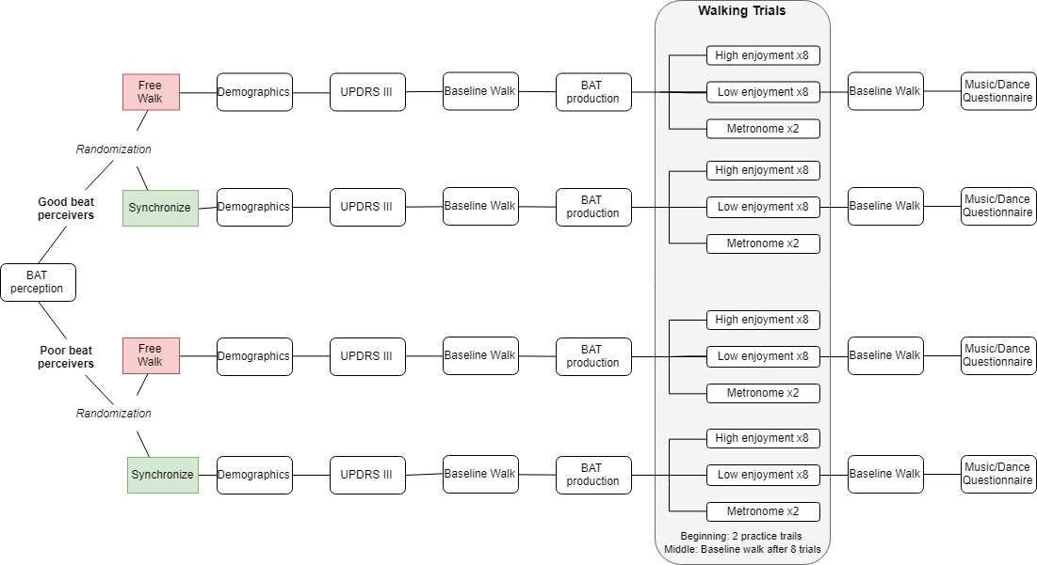
Figure 2. Complete study procedure.

Table 1
Participant Demographics Characterized by Condition Type
 |  | Good Beat Perceivers |  |  | Poor Beat Perceivers
 | Free Walking (N = 8) |  | Synchronized (N = 6) | Total (N = 14) | Free Walking (N = 7) | Synchronized  (N = 7) | Total (N = 14)
Age M (SD) |  | 67.60 (12.60) | 63.20 (5.07) | 65.40 (9.35) | 68.20 (6.42) | 72.71 (9.91) | 70.83 (8.60)
Sex (% male) |  | 50.00 | 83.33 | 64.28 | 71.43 | 85.71 | 78.57
BAT Perception  M (SD) |  | 0.75 (0.09) | 0.78 (0.12) | 0.77 (0.10) | 0.50 (0.10) | 0.52 (0.08) | 0.51 (0.09)
Modified Hoehn Yahr Scale Score  M (SD) |  | 1.88 (1.13) | 2.83 (0.98) | 2.33 (1.11) | 3.14 (.38) | 3.29 (0.76) | 3.21 (0.58)
Abnormal Hearing (%) |  | 37.50 | 0.00 | 21.43 | 0.00 | 42.86 | 21.43
Music Training (%) |  | 37.50 | 100.00 | 64.29 | 14.29 | 57.12 | 35.71
Dance Training (%) |  | 25.00 | 16.67 | 21.43 | 14.29 | 0.00 | 7.14

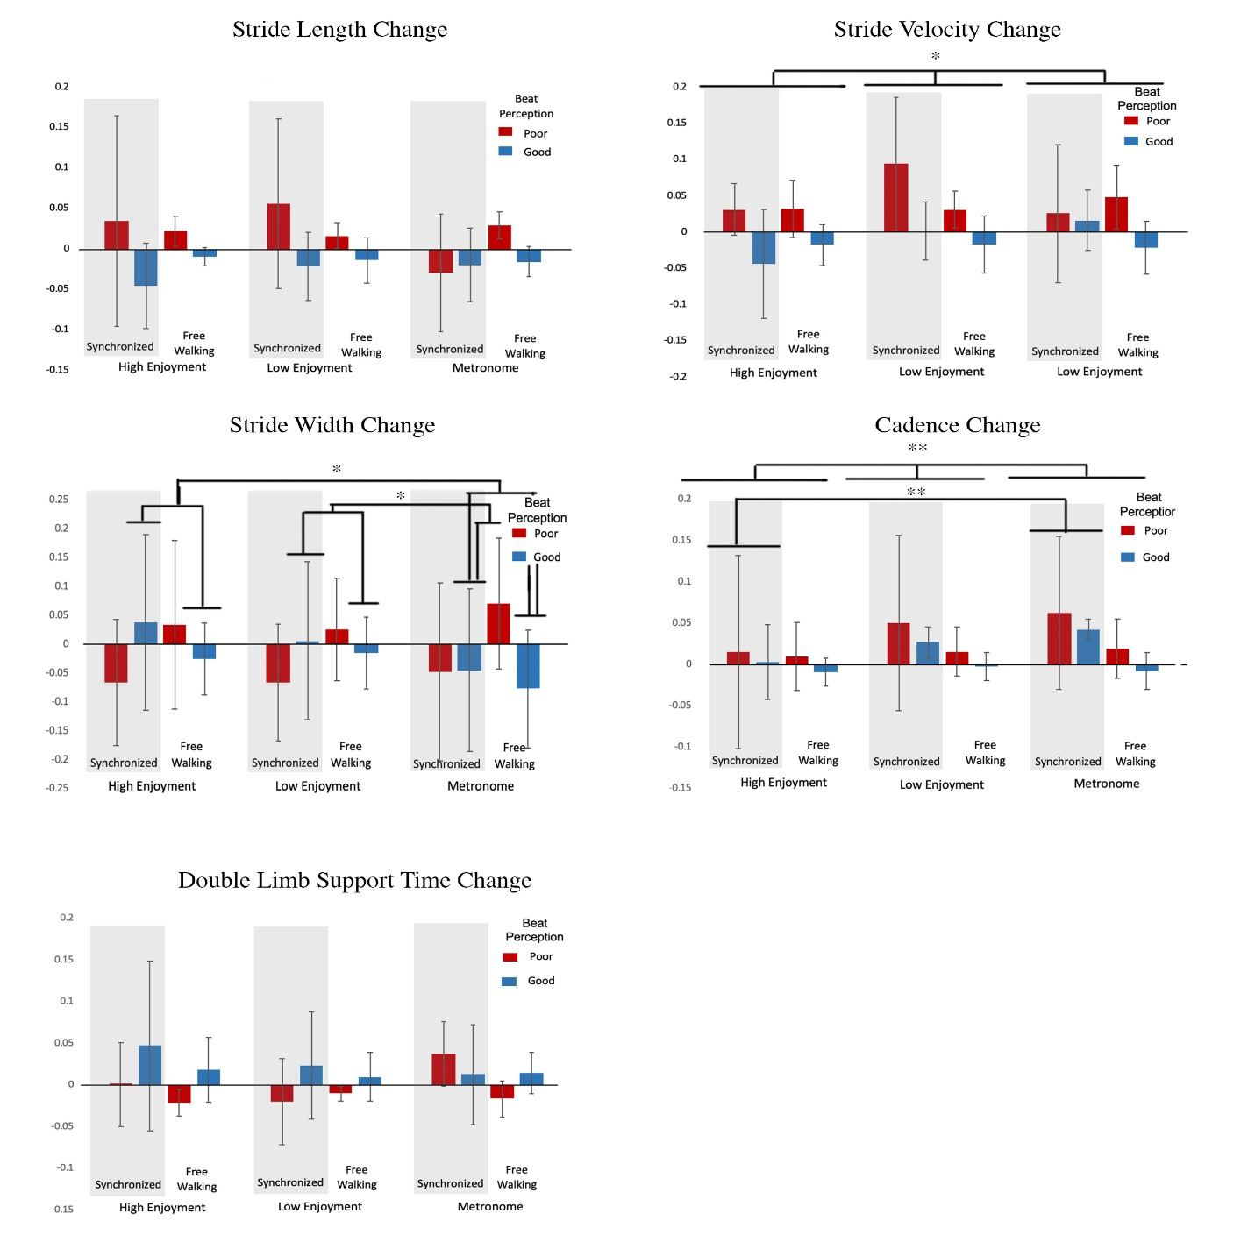
Figure 3. Graphs for all gait measures wherein the red bars represent those characterized as poor beat perceivers and the blue bars represent those characterized as good beat perceivers. The gray shading represents synchronized trials and the non shaded area represents free walking trials. Significance levels are shown only for within subject results that had significant post hoc analyses. Significance levels are indicated by * wherein * represents p < .05 and ** represents p < .01.
Appendix A
Demographics and Dance/Music Questionnaire
Questionnaire administered to participants using Qualtrics. Link: https://qtrial2018q4az1.az1.qualtrics.com/jfe/form/SV_6wXSaJdFqhBZOfj
Part I: Demographics
FOR THE RESEARCH ONLY: Participant number (e.g., ES001 or EFW001) ______________

What is your biological sex?

Male Female

What is your age? _______________________________________________________________

Do you take psychotropic drugs either recreationally or medicinally?

Yes No

If yes, please describe: __________________________________________________________

How many years of education have you had since grade one? ___________________________

What is your handedness?

Right Left Ambidextrous

Do you have normal hearing?

Yes No

If you indicated no, please elaborate: _______________________________________________

Part II: Music/Dance
Do you have any formal music training (either vocal or instrument)?

Yes No

Which instruments? _____________________________________________________________

Please list the age in which you began playing each instrument (or singing)? ________________

Please list the total number of years of training you have for each instrument: ______________

Which type of training did you receive?

Self Taught Private Lessons School/Band

Family/Friends Other

If indicated other, please specify? __________________________________________________

When was the last time you practiced or performed? __________________________________

Do you have formal dance training?

Yes No

What style(s) of dance? __________________________________________________________

Please list the age at which you started dance? _______________________________________

Please indicate the total number of years of training: __________________________________

Which type of training did you receive?

Self Taught Private Lessons School/Band

Family/friends Other

If indicated other, please specify: __________________________________________________

When was the last time your practiced or performed? __________________________________

Have you ever participated in a gait study before?

Yes Maybe No

What type of music do you prefer to listen to?

Pop Country Blues/Jazz

Rap/Hiphop Classical Soul/Funk

Folk Other

If you indicated other, please specify below: _________________________________________

Appendix B
Songs used for stimuli

Song Name | Artist | Genre
Albatross | Unknown | German Folk
Bgmusic | Catherine Michael | Rhythm and Blues
Bourree | Unknown | German Folk
Bryter Lyter | Nick Drake | Folk
Candy Rock | Unknown | Rock
Conmigo Pachanga | Eddie Palmieri | Latin
Cripple Creek | Unknown | German Folk
Druid Fluid | Yo-Yo Ma, Edgar Meyer | Classical
Eye of the Tiger | Lucy Chomps | Rhythm and Blues
Flamenco Chill | Unknown | Latin
Flip Flop | Unknown | German Folk
Halo | Michael Salvatori | Film
His Hand | Unknown | German Folk
King | Unknown | German Folk
Kus Kus | Unknown | German Folk
Louisiana | Unknown | German Folk
Merengue Mambo | Unknown | Latin
Midnight Storm | Unknown | Ambient
Missy Elliott | Missy Elliott | Hip Hop
Music Magic | Unknown | German Folk
Muy Tranquilo | Unknown | Hip Hop
Nobles Mystic | Unknown | German Folk
Once More | Unknown | German Folk
Peach Fuzz | Unknown | German Folk
Somewhere In My Car | Keith Urban | Country
Surfing | Unknown | German Folk
Sweet Child | Unknown | German Folk
The Drunk | Unknown | German Folk
Twangy | Unknown | Country
Wolves | Digitalism | Electronic Music
Zone | Unknown | German Folk
Zumba Latina | Unknown | Latin

